Q3)
a) Wireshark
Wireshark is a GUI-based network protocol analyzer that allows you to capture, analyze, and troubleshoot network traffic. It is widely used by network engineers, cybersecurity experts, and developers to inspect packets in real time.

I) Installation
a) On Linux
sudo apt update && sudo apt install wireshark -y
b) On Windows
Download Wireshark

ii) Launching in Linux
sudo wireshark

iii) Capturing N/W Traffic
a) Select Interface
b) Click Start
c) Click Stop
d) Save as .pcap file

iv) Filtering Packets

sudo wireshark -i wlp0s20f3 -k -Y "http"
ip.addr == 192.168.1.100 Show packets involving a specific IP
tcp Show only TCP packets
udp Show only UDP packets
http Show only HTTP traffic
icmp Show only ICMP (ping) traffic
dns Show only DNS queries/responses
tcp.port == 80 Show only packets on port 80 (HTTP)
ip.dst == 142.250.185.14 Show packets from google.com

TCP FILTER
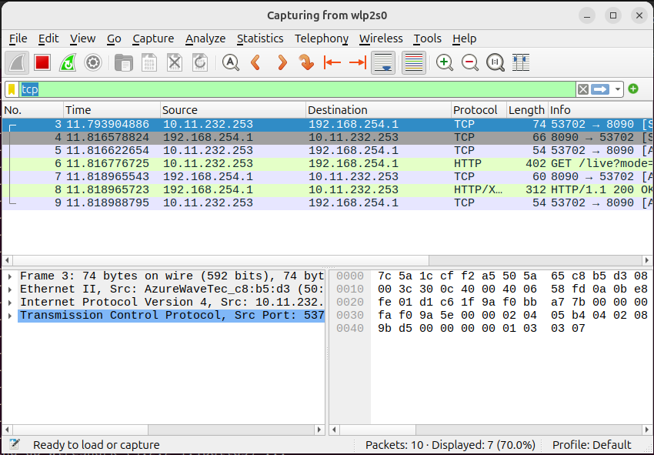

b) TCP DUMP

tcpdump is a command-line network packet analyzer that captures and inspects network traffic in real time. It’s a lightweight alternative to Wireshark for quick debugging and analysis.

I) Installation
sudo apt update && sudo apt install tcpdump -y
Verify the installation by
tcpdump –version
ii) To check the interface
tcpdump -D

1.wlp0s20f3 [Up, Running, Wireless, Associated]
2.any (Pseudo-device that captures on all interfaces) [Up, Running]
3.lo [Up, Running, Loopback]
4.bluetooth0 (Bluetooth adapter number 0) [Wireless, Association status unknown]
5.bluetooth-monitor (Bluetooth Linux Monitor) [Wireless]
6.nflog (Linux netfilter log (NFLOG) interface) [none]
7.nfqueue (Linux netfilter queue (NFQUEUE) interface) [none]
8.dbus-system (D-Bus system bus) [none]
9.dbus-session (D-Bus session bus) [none]

iii) To capture packets on specific interfaces

sudo tcpdump -i wlp0s20f3 // capturing packets on specific interface

sudo tcpdump -i wlp0s20f3 -w capture.pcap // store the captured packets to the file

tcpdump -r capture.pcap // read from a .pcap file
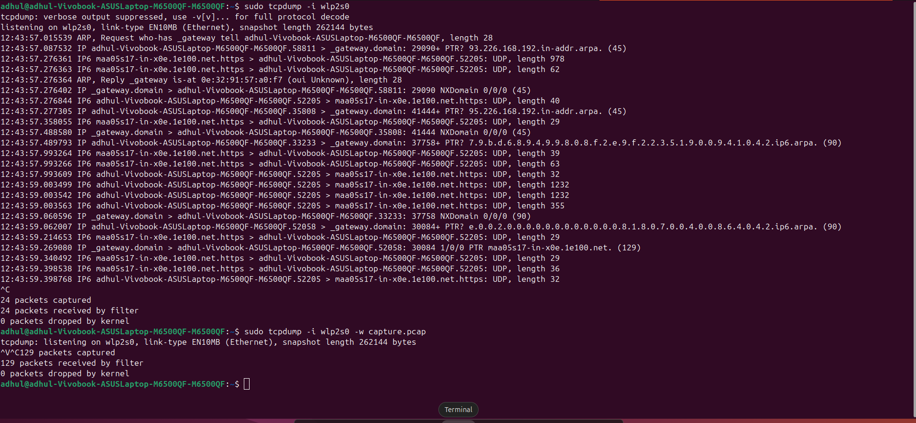

sudo tcpdump -i wlps0s20f3 port 80 // capture HTTP traffic

sudo tcpdump -i wlps0s20f3 tcp // capture tcp packets

sudo tcpdump -i wlps0s20f3 host 192.168.1.100 // capture packets to/from the host

sudo tcpdump -i wlp0s20f3 -A // capure and show packets in readable format

sudo tcpdump -i wlp0s20f3 -X // show captures packets in both hex nd ascii format

sudo tcpdump -i wlp0s20f3 -c 10 // capture limited packets

c) Cisco Packet Tracer

